Hello to you

Back again so soon you might say! The Committee, Coordinators and those holding portfolio positions have been busy getting us lined up for an amazing 2024/25 season and have info to share with all.

The big-ticket item is Club Opening Day 16th November, more info in this edition.

Moving forward we are seeking newsworthy items for our next publication from Committee/ Coordinators and players. If you wish to input, please email [tracy.adams@westnet.com.au.](mailto:tracy.adams@westnet.com.au.%20)  Happy Hitting folks

**Edition 4**

|  |
| --- |
| **COMMITTEE REPORTS** |

|  |
| --- |
| FUNCTIONS REPORT |

Inaugural Busselton Tennis Club Open Day - Memories from 2019 Match Committee: -

Five years since the official opening of our fabulous new clubhouse on 23rd November 2019 with our guest of honour Margaret Court.

Memories of 227 playing members, former members and visitors who came from far and wide to play on our courts.

Our newly designed Tennis Pro sets system (created by Busselton's Paul Coshott) being put to the test. Starting tennis early so 12 rounds of tennis could be played, 6 before afternoon tea and 6 after. Captain Allison Hutchison and V/C Sue Thomas entering names and making up sets on Tennis Pro and V/C Maureen McDaniell backing up using the old computer and sets system (Matcho) just in case there was a hiccup. It was quite a challenge, but it all worked out well and Tennis Pro performed perfectly.

Though we must admit the refreshments at Court 28 went down well at the end of the day.

Behind the scenes for the Busselton Tennis Club Open Day

We are ready ….With carpets cleaned by Yutai, windows sparkling (many thanks to Chris Roe), and clubhouse exterior looking its best (thanks B Team) the clubhouse is ready for our 5th Opening Day

Raffle: tickets for sale during the afternoon thanks to Maureen

Afternoon tea at 3.30pm: thanks to Barb and our volunteers

Finger food in the evening: thanks to Functions catering team

Come along and have a chat with members past and present and enjoy refreshments at Court 28.

|  |
| --- |
| **PROGRAM & PORTFOLIO REPORTS** |

|  |
| --- |
| COURT 28 BAR |

The Bar is always on the lookout for additional support. Is this something you would like to do to meet your “Voluntary” commitment to the club.

All you need is your winning smile, enthusiasm and hold or attain ‘Responsible Service of Alcohol’ accreditation.

Wayne or Ken will be happy to assist you in meeting this requirement. It’s not arduous at all

To hold the required Bar Licence for club members benefit we also need to affiliate another Approved Bar Manager.

Do any of our members currently hold or would be willing to obtain the essential ‘Approved Managers’ accreditation? Any costs incurred will be met by the club.

|  |
| --- |
| CLUB CALENDAR |

Club Captains have compiled our Calendar of events for the 2024/25 season including Handicap and Championship Events coming up 8th and 14th of December. Please pop these important events into your calendars now.

The full Calendar of events schedule will be available at the Captains desk for all members.

|  |
| --- |
| UPCOMING EVENTS TO POP IN YOUR CALENDAR |

* BUSSELTON Tennis Club Opening Day –16TH November
* HANDICAP MIXED DOUBLES 7TH -8TH December (depending on numbers, event may start 3pm Sat)
* HANDICAP SINGLES 14th – 15th December (depending on numbers, event may start 3pm Sat)
* CHRISTMAS SOCIAL DAY – 21st December
* GALA DAY – Tentatively 13th February 2025

|  |
| --- |
| CLUB OPENING DAY |

Official Club Opening Day. Play will commence at 2pm, Club Patron Libby Mettam will officially open the season during tea break. Plenty to see and do, tennis, with novelty prizes, , raffles and lovely arvo tea and finger food later on. Come along play, or just join us during the afternoon for the joy of tennis.

|  |
| --- |
| VOLUNTEER COMMITTMENT |

The viability of Busselton Tennis club success is derived from the generous support of members who willingly offer their time and energy. Currently our Committee & Coordinators all undertake their responsibilities in a voluntary capacity.

Please don’t hesitate to show your gratitude to these people when given the opportunity.

Wayne and his team wish to remind all members that all communication should be undertaken professionally and respectfully, being mindful that our Committee & Coordinators are juggling their time between club, family and personal responsibilities

The Committee encourage all feedback and appreciate your time to provide it, we are always working to improve

members experience at Busselton Tennis club.

|  |
| --- |
| HAVE A HIT FRIDAYS |

The *Have a Hit* (HAH) program kicked off on October 18, a small contingent of players showed excitement and enthusiasm even though the weather was a little gloomy for the start of the season.

Week No 2, October 25th, we hosted a tremendously successful Junior Club Open Day, with over 90 young players and their families enjoying our superb facilities.

A highlight of the evening was the free raffle of 10 Junior Memberships, generously sponsored by Busselton Toyota and drawn by General Manager Simon Fairbrother.

Thank you to all participants, volunteers, and sponsors for making these events a wonderful success—what a great start to the season!



|  |
| --- |
| ***HAH Fridays are only possible because of ‘Volunteer’ contributions of time, if you have elected to undertake a ‘discounted’ Club Membership consider making HAH one of your tasks*** |

|  |
| --- |
| PICKLEBALL |

Pickleball Open day Sunday 27th October saw 50 players take the courts. This group is growing in numbers as quickly as the sport’s worldwide popularity.

So, we have now marked out more Pickleball courts to cater for our growing Pickleball community and more sessions added to the schedule.

To register and play Pickleball, it is recommended that you download the Stack App.

Once downloaded click on the little magnifying glass and type in “Pickleball Busso Tennis Club”, once app finds team click on the button that says, ‘add me to team’.

Admin will accept your request, and you will be ready to book sessions. Sounds tricky, but it really is not. If you need a hand reach out to Ken, or pop by at one of the sessions times, meet the crew and someone will get you started.

|  |
| --- |
| **GENERAL INFORMATION** |

|  |
| --- |
| COURT CARE |

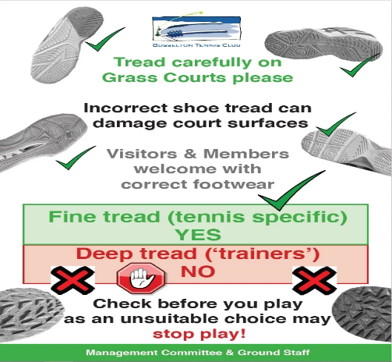

As members we individually need to take personal responsibility to support Chris and his A Team’s attentiveness in providing and maintaining our club with impressive grass courts which are consistent in being the best grass courts in WA.

We can do this by ensuring we all have correct footwear ideally a grass court shoe, which is a shoe with a low profile and a flat outer sole.

Some CROSS TRAINER and HARDCOURT shoes will damage courts, resulting in courts being withdrawn for member use until it repairs.

|  |
| --- |
| ANNUAL GENERAL MEETING |

Kudos to our current Committee, we thank you for your efforts as you support our club by volunteering your time and expertise.

It is probably time to remind members that the AGM is only 6 months away. We have all been put on notice that there are several positions that will need to be filled based on end of term in role.

It will be an opportunity to identify and elect a new energetic leadership group who will have opportunity to drive our Club forward.

Let’s start talking about this now as it is us the members responsibility to seek new committee and leadership for our club.

|  |
| --- |
| 2024/25 MEMBERSHIPS - HAVE YOU AND HOW TO ? |

Did you know that

* if you have any questions regarding membership you can reach out by email to [membership@busseltontennisclub.com.au](mailto:membership@busseltontennisclub.com.au)
* you can pay your membership electronically online, go [Busselton Tennis Club Website](https://www.busseltontennisclub.com.au/members) and look for ‘membership tab’
* you can pay in cash or with card in person at either the Captains Desk or Bar
* that you can save $100 on full membership cost by undertaking a range of ‘Voluntary’ Activities that suit you as an individual
* we also offer Social Memberships for just $30, this offers reduced costs for some club functions / Pickleball and off course you will de added to our email list for all club communications

|  |
| --- |
| HOUSE-KEEPING |

It is important for us all to be diligent when it comes to the security of our premises. There has been a few recent occasions where gates have not been closed properly and external doors not locked. It is up to us all to be part of our club’s security, please be mindful and vigilant.

If you happen to see Kim, give her a “high five” for her efforts in maintaining our facility gardens, we are so lucky to have fabulous gardens.

Reminder …. if you use it put it away, pop you chair back under the table when you leave, stack outdoor chairs back under cover …. These simple routine tasks will make it much easier on our members to the secure premises when leaving.

|  |
| --- |
| CHIT CHAT |

City of Busselton’s Sports Award night saw our Wendy Weir accept the **Lifetime Achievement award**, congratulations Wendy from all of us at Busselton Tennis Club.

Ken and Wendy are entertaining lifelong friends from Canada, if you see them be sure to say hi.

Brian and Kathryn have just returned from Ireland ready for the summer season of tennis.

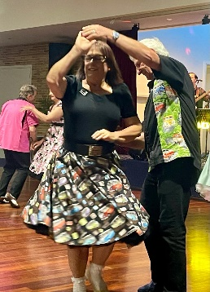



Moonlighter Spotted!

MORE CHIT CHAT!

!

Look who we found flitting, twirling, moving and grooving around the dance floor.

It appears that this person has light feet on and off the court and has a life outside of tennis….who would have thought?

|  |
| --- |
| BRAIN TEASER ALERT! COACHES CORNER |

 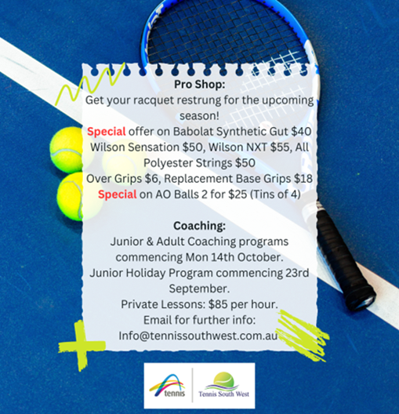

**Court 28 news needs your input, please send through your funnies, trivia or puzzles for us to share.**

**Thanks to Dennis Schram for this editions Brian Teaser**

***Busselton Tennis Club would like to recognise and thank our generous sponsors. We encourage our club members to acknowledge and support our sponsors whenever possible***

